Healthcare Analytics

Problem Statement:

- The project aims to analyse healthcare data, focusing on extracting meaningful
- insights about patients, doctors, appointments, diagnoses, and treatments using
- advanced SQL techniques. Learners will apply SQL operations like joins, subqueries,
- window functions, and more to analyse healthcare metrics.
- Business Use Cases:

Patient Management: Analysing patient demographics, their medical histories, and appointment trends.
Doctor Performance Evaluation: Measuring doctor efficiency by tracking diagnoses and treatment frequency.
Appointment Scheduling & Completion: Understanding appointment trends, cancellations, and completions.
Medication Analysis: Identifying the most common medications prescribed to patients based on diagnoses.
Revenue and Billing Analysis: Linking appointment data with billing information to understand revenue generation.

Project Overview
This project focuses on designing and querying a Healthcare Database using SQL. The objective is to analyze patient, doctor, appointment, diagnosis, and medication data by applying different SQL concepts such as joins, subqueries, window functions, conditional expressions, and aggregation.
The project demonstrates real-world healthcare use cases like tracking completed appointments, identifying inactive patients, analysing doctor performance, and understanding prescription patterns.

Database Setup
CREATE DATABASE healthcare;
USE healthcare;
Tables Used
- patients – Stores patient demographic and contact details
- doctors – Contains doctor profiles and specializations
- appointment – Manages appointment records between patients and doctors
- diagnosis – Records diagnoses made by doctors for patients
- medications – Stores prescribed medications with duration details

Task 1: Inner & Equi Join – Completed Appointments:

Objective: Fetch all completed appointments with patient name, doctor name, and specialization.
Concepts Used: INNER JOIN, filtering
Outcome: Helps track completed consultations and doctor involvement.
Output:
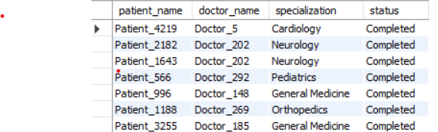

Task 2: Left Join with NULL Handling – Patients Without Appointments
Objective: Retrieve patients who have never had an appointment.
Concepts Used: LEFT JOIN, NULL filtering
Outcome: Identifies inactive or newly registered patients.
Output :

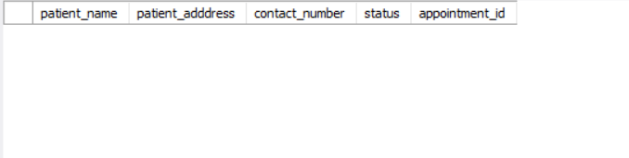

Task 3: Right Join & Aggregation – Diagnoses per Doctor
Objective: Count total diagnoses for each doctor, including those with zero diagnoses.
Concepts Used: RIGHT JOIN, COUNT(), GROUP BY
Outcome: Evaluates diagnostic workload and identifies underutilized doctors.
Output :
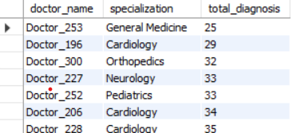

Task 4: Full Join – Mismatch Detection
Objective: Identify mismatches between appointments and diagnoses.
Concepts Used: FULL JOIN (logical concept), data reconciliation
Outcome: Helps detect missing or inconsistent medical records.
Output:
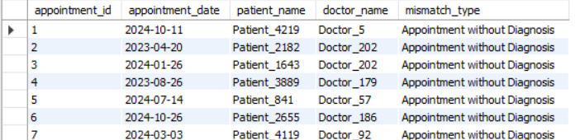

Task 5: Window Functions – Ranking Patients per Doctor
Objective: Rank patients for each doctor based on number of appointments.
Concepts Used: RANK(), PARTITION BY, aggregation
Outcome: Highlights frequent patients and doctor-patient engagement.
Output:
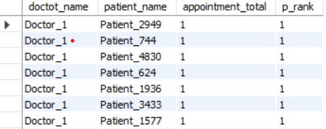

Task 6: Conditional Expressions – Patient Age Groups
Objective: Categorize patients into age groups and count them.
Concepts Used: CASE statement, GROUP BY
Outcome: Supports demographic analysis and age-based planning.
Output:
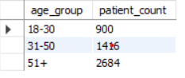

Task 7: Numeric & String Functions – Contact Filtering
Objective: Retrieve patients whose contact numbers end with '1234' and display names in uppercase.
Concepts Used: LIKE, UPPER()
Outcome: Demonstrates string manipulation and pattern matching.
Output:
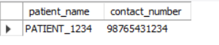

Task 8: Subqueries & Filtering – Insulin-only Patients
Objective: Identify patients prescribed only Insulin.
Concepts Used: Subqueries, HAVING, DISTINCT
Outcome: Helps analyze treatment-specific patient groups.
Output:
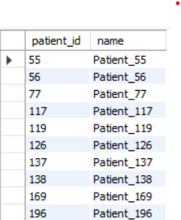

Task 9: Date & Time Functions – Medication Duration
Objective: Calculate average medication duration per diagnosis.
Concepts Used: DATEDIFF(), AVG()
Outcome: Evaluates prescription timelines and treatment duration.
Output:
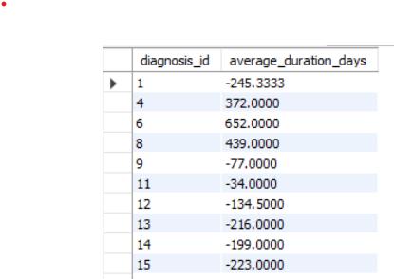

Task 10: Complex Joins & Aggregation – Doctor with Most Unique Patients
Objective: Identify the doctor who attended the highest number of unique patients.
Concepts Used: DISTINCT, JOINs, aggregation, sorting
Outcome: Measures doctor reach and patient diversity.
Output:
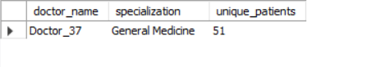

Key SQL Concepts Demonstrated
- Inner, Left, Right Joins
- Aggregation & Grouping
- Window Functions
- Conditional Logic
- Subqueries
- Date & String Functions

Conclusion
This Healthcare Database project effectively demonstrates the application of advanced SQL concepts to solve real-world healthcare data problems. The queries provide meaningful insights into patient behaviour, doctor performance, appointment trends, and medication usage. This project serves as a strong foundation for healthcare analytics, reporting, and database-driven decision-making.

